How to setup a cluster with SAMOA framework
---- Experience of my master project
Li Huang
CECS, University of Louisville
2014.5.6

In my last semester of my master program study on Spring 2014, my advisor, Dr.Kantardzic, suggested me to do a research on Yahoo SAMOA as my final project. It is a new framework for distributed stream data mining, which is a new and interesting research area for me, so I accepted to do this research.

The first thing was to understand what SAMOA is. So at first I visited the official website(http://yahoo.github.io/samoa/) and read some papers written by the major creators of SAMOA project: “SAMOA Developer Guide”, “SAMOA: A Platform for Mining Big Data Stream”(Gianmarco De Francisci Morales), “Distributed Decision Tree Learning for Mining Big Data Streams”(Arinto Murdopo) and “Scalable Distributed Real-Time Clustering for Big Data Streams” (Antonio Loureiro Severien).

Setup
After got some initial impression about SAMOA, I needed to try it. So I search the way to setup it. The official website did not show intuitive guide for setup, so I firstly search the other people’s experience on setup SAMOA. I found a guide written in Chinese which was perfect for me. It told about how to setup SAMOA with Twitter Storm on Ubuntu Linux. I followed this guide trying to setup SAMOA on my virtual machine, but failed to setup Storm at last. Therefore I checked back the install instruction on SAMOA’s official website, and this time I choose to setup SAMOA with Yahoo S4. It was easier to setup S4 than Storm because S4 does not need much configuration, and all the computer nodes plays same role; with Storm, a computer is “master” and the others are “worker” you must configure the “master’s” IP in each “worker”. (Storm and S4 are two Stream Processing Engine that SAMOA supports, you can also search “S4 vs Storm” on the Internet to compare these two different platform.)

I was not familiar with Linux, but I tried to use some different Linux’s before. In my experience, Ubuntu is a popular and stable one with great compatibility and support. So I chose to setup the latest Ubuntu desktop (v12.04) in my laptop virtual machine. If you are not familiar with Linux, do not try to setup Ubuntu Server version because it has no GUI desktop but only text console.
After setup Linux, I follow the instructions on SAMOA’s official websites, firstly setup S4 then setup SAMOA. Maven, Gradle, JDK and Git are also needed to setup as precondition. This process is complex and frustrating at first time, and I summary the whole setup steps in my “Yahoo SAMOA whitepapers” (Search ‘Yahoo SAMOA white paper’ or access my Google Drive at https://drive.google.com/folderview?id=0B0k3wDoweGSZUnBiNmpiWUFfY2c&usp=sharing).

The next step is setup my experiment cluster in the lab. I applied for 3 idle computers in CECS department of my school, and got them soon. They are old computers with Pentium4 1.8Ghz CPU and about 500MB RAM. I did the same setup steps that I setup Ubuntu,S4 and SAMOA on each of these computers. In fact, later I found only 1 computer need setup SAMOA, while the other two nodes only need setup Ubuntu and S4. The old computers have many problems at first, but fortunately I got disinterested help from our department’s device maintaining team, Rachel and Ron, who displace the video card, monitor, DVD-ROM and switch power adapter. At last I connect the computers to a switch, and this switch is also connected to our school’s network (through the plug on the wall) that all the three nodes could access Internet. So these computers composed a 3-nodes cluster. After try a basic task of SAMOA on this cluster and found it could run correctly. Until that time, I finished the first step of my project -- setup SAMOA on cluster. Therefore I did a presentation to my classmates in the Data Mining Lab.

The detail setup process could be seen in my “white papers”. The cluster in my lab is shown in the diagram below:
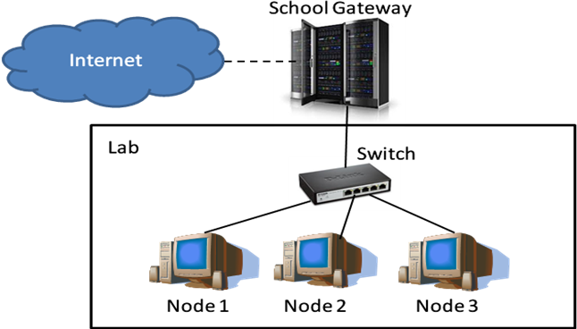
Hardware | Software
node1: Pentium4 1.8Ghz, 576 MB RAM  node2: Pentium4 1.8Ghz, 768 MB RAM  node3: Pentium4 2.35Ghz, 495 MB RAM | Ubuntu Linux Desktop ver12.04 32-bit  Yahoo S4 ver0.6  Yahoo SAMOA ver0.0.1

Experiments
After setup SAMOA, the second step is trying to use it. The first application I did was repeating the process of “Getting Start in 5 minutes” on SAMOA’s official website. It was a task to classify the “Forest Cover Type” dataset with SAMOA’s default classifier, Vertical Hoeffding Decision Tree. After the initial try, I did 3 more experiments.

Lab 1: Test performance of SAMOA
The next experiment was testing speed of SAMOA in different cluster configuration, say, with 1 node, 2 nodes, and 3 nodes. I still used the default classifier, Vertical Hoeffding Tree (VHT). The result shown running SAMOA on single node in local mode (without S4) was the fastest way; running on S4 mode, 2-nodes configuration increased the classification speed than 1-node, but in most situations 3-nodes configuration decreased the speed than 2-nodes. So I guessed it was SAMOA’s problem or the test data’s problem. Therefore I choose bigger and real datasets in next experiments.

Lab 2: Implement Non-Parallel Naive Bayes in SAMOA
In this experiment, I implement two different Naive Bayes classifiers. Moreover, I choose 3 realistic datasets, MovieReview, Kdd99 and NslKdd as testing dataset. In this experiment. Through this experiment, I learnt how to create a user-defined data mining algorithm in SAMOA. Beasically you need to do is to inherit the Learner class with your own algorithm. Because it was the first time writing code in SAMOA, this lab took me much time in design and read reference material for Naive Bayes algorithm. In addition, I met some bugs of SAMOA and feedback them to the developing team of SAMOA, some fixed some was still left. However, this algorithm was non-parallel, so when I ran it on cluster, only 1 node worked and the other two were idle. The result of Lab 2 shown the classification speed decreased, rather than increased, with more nodes. Another notable thing is the default task of SAMOA, “PrequentialEvaluation” considers each instance from datasource as both training data and testing data, and the learner is training and classifying at the same time. The figures below shows the structure of my Naive Bayes algorithm and the experiment result.
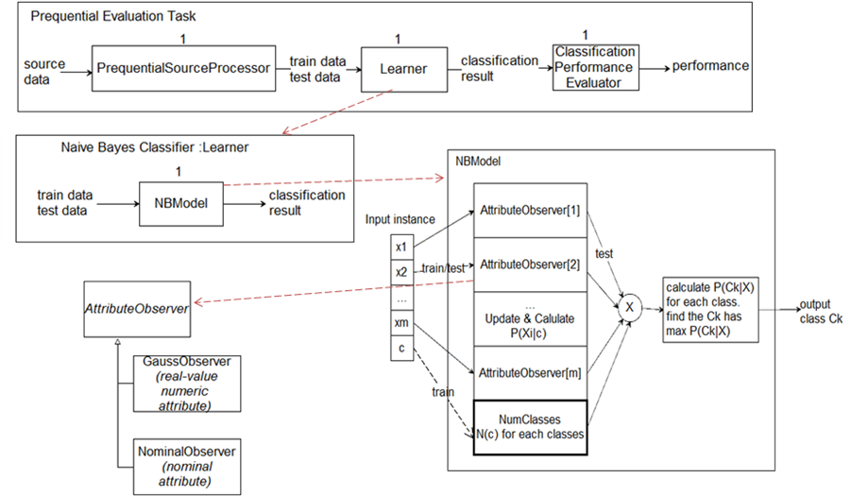

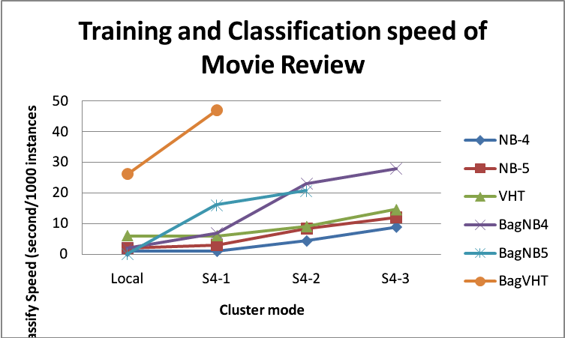
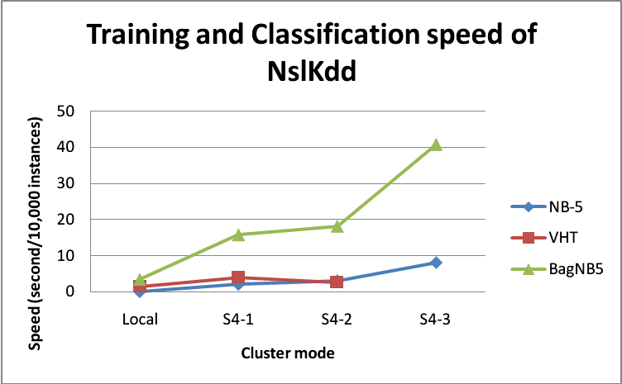
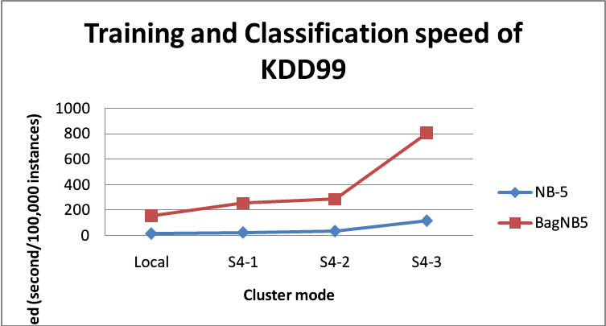

Lab 3: Implement Parallel Naive Bayes in SAMOA
In my final experiment, I developed a parallel version of Naive Bayes. Then I test whether it could get higher performance with more nodes. Unfortunately this algorithm failed to achieve higher performance with more nodes but decreased the speed. I still took so much time on this experiment because I met some bugs while run this algorithm in S4 mode, and I could not find the way to fix the bug but had to change my algorithm design. The diagram below shows the structure of this algorithm.
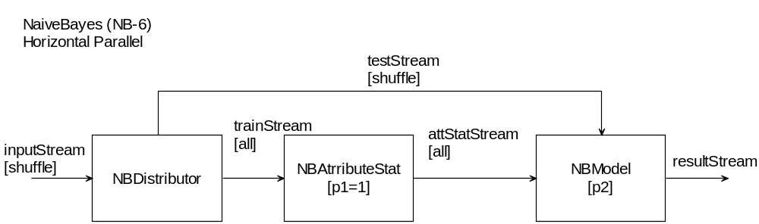
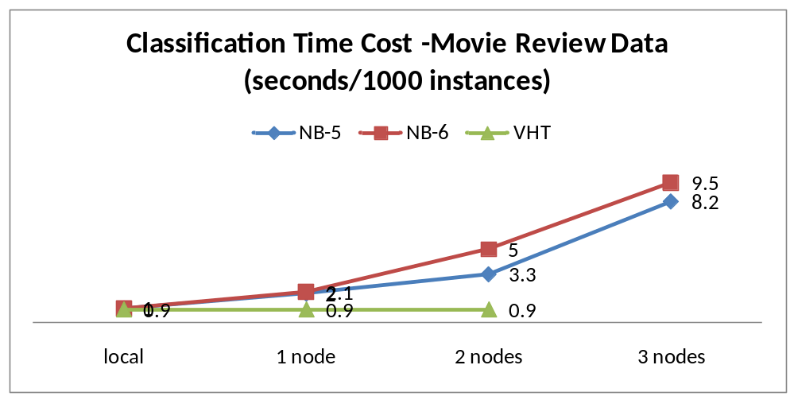
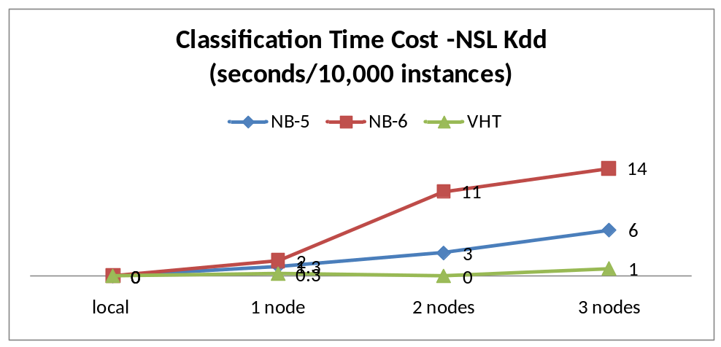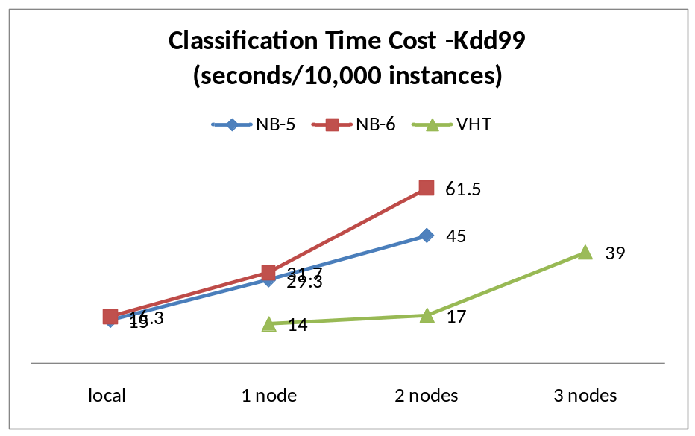

All the lab reports and codes could be found on my Google drive:
https://drive.google.com/?usp=chrome_app#folders/0B0k3wDoweGSZblZ1THBHaXptNDg

Conclusion
This project opens a window of streaming data mining to me. And I also gained much experience on create cluster for data mining. Although the experiment results shown so far SAMOA still has many problems and might is not as good as it promised, I expect it could be improved in the future.

Announcement
At last, I should thank to my advisor Dr. Kantardzic who leads me into the area of data mining and provided much support for my project; Thanks to my colleagues in Data Mining Lab, T.J., Hanqin and Elley, who gave me great help and encouragement; Thanks to all the respectable professors, smart classmates and helpful staffs in CECS, where I feel proud of. At last thanks to my parents who have supported me so much in my life.

